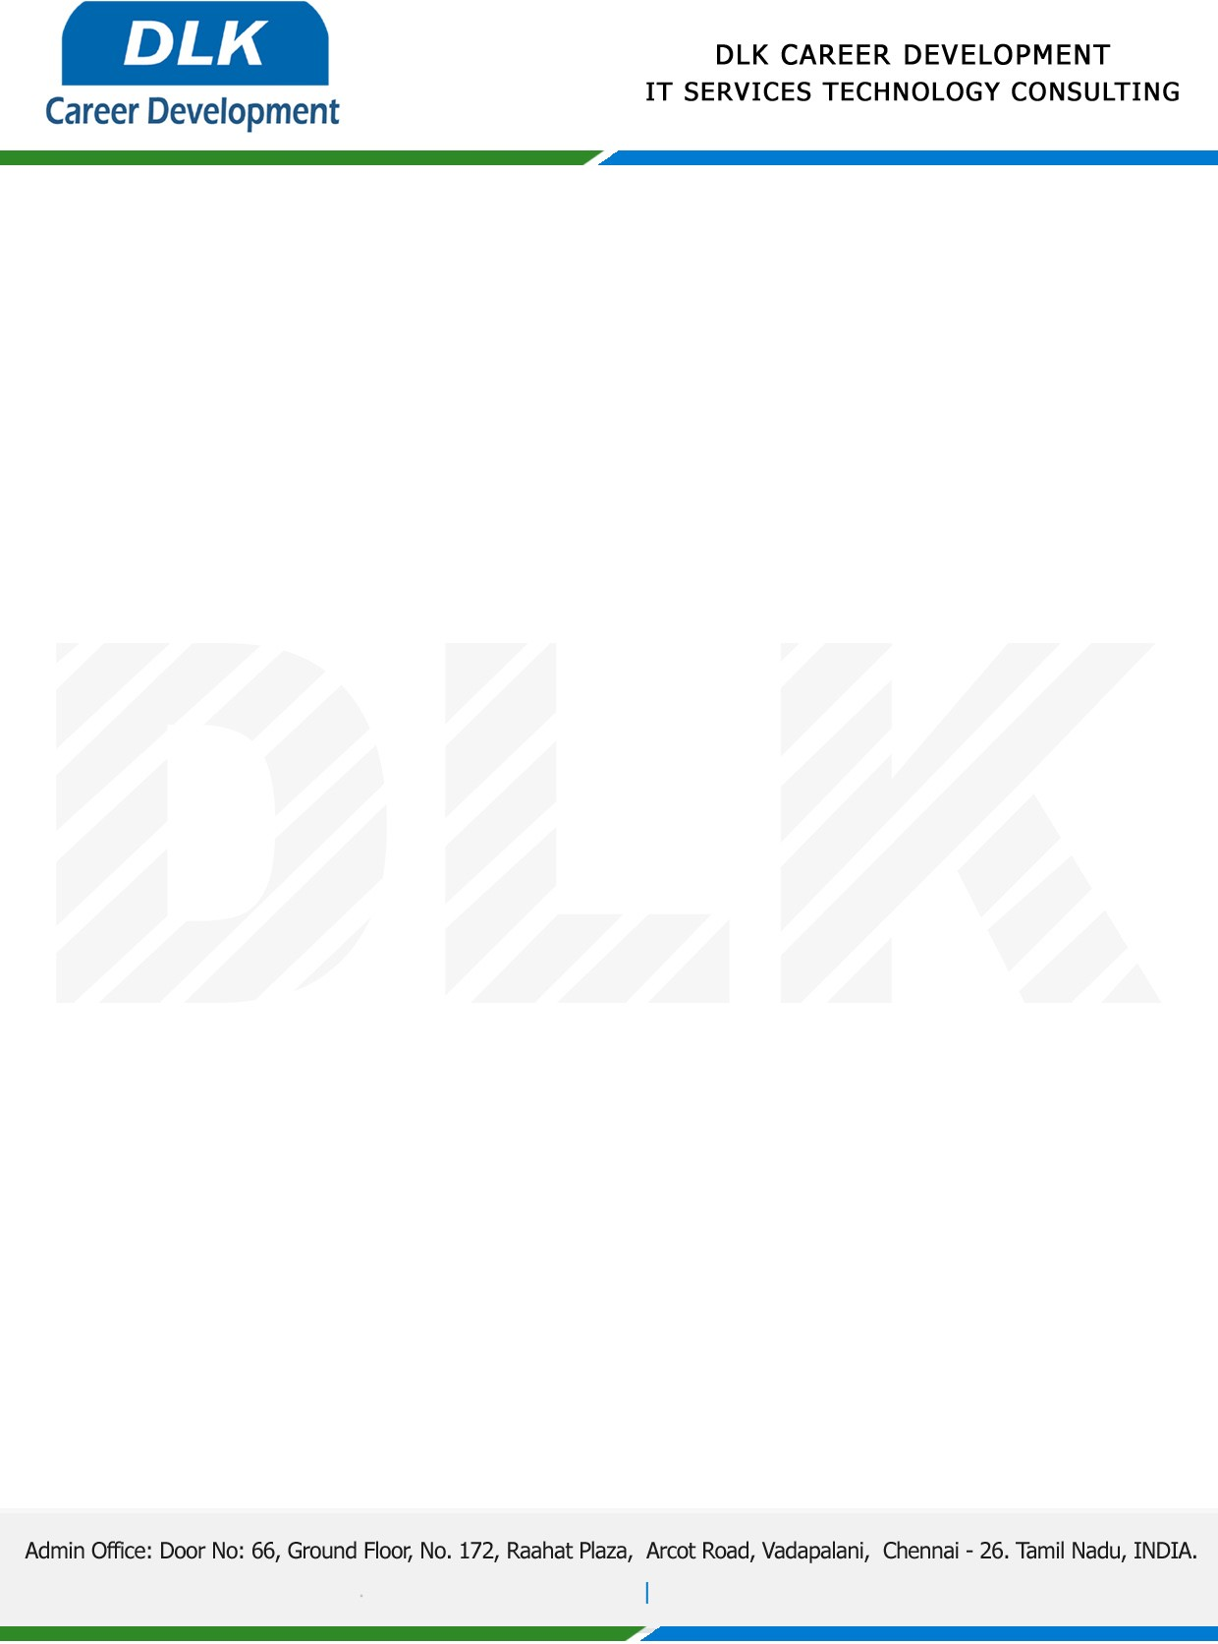

**Date: 19/ April/2023**

**SUB: PROJECT COMPLETION CERTIFICATE**

This is to certify that **MS VASANTHI A (REG NO: 212004066) MSC- Computer Science,** final year student **Jaya College of Arts And Science, Chennai** has Successfully Completed the Project Work under the domain of “**Java”** in our organization during the Period **(06th January 2023 to 06th April 2023).**

**Topic:** Online based Visa Granted and Renewal Information system.

We appreciate your interest in **DLK CAREER DEVELOPMENT**

**“Best Wishes for Your Future Endeavors “**

